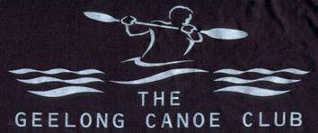

Geelong Canoe club - By Law
Date: 18/12/2020
By Law #: 7a
By Law Title: Funds accrued from sale of unclaimed boats
Date Created: 17/12/2020
Date Reviewed: TBA
To: Geelong Canoe Club Members
From: Geelong Canoe Club Committee

PURPOSE
To describe procedures for handling of money gained from the sale of unclaimed boats.

PROCEDURE
All unclaimed boats which the General Committee of the club propose for sale will be sold after the 3-month period from Boat Registration Day and the money received will be used to:

- cover unpaid storage fees,
- club beginner activities,
- building improvements
- improvements associated with the maintenance, repair and storage of boats

